**PURBANCHAL UNIVERSITY**



**DEPARTMENT OF COMPUTER ENGINEERING**

**KHWOPA ENGINEERING COLLEGE  
LIBALI-2, BHAKTAPUR**

**A FINAL PROJECT REPORT**

**ON**

**MOVIE TICKET BOOKING SYSTEM**

Project work submitted in fulfilment of requirements for the award of the degree of Bachelor of Engineering in Computer Engineering (Fourth Semester)

**Submitted By:**

Rohan Kaju (750330)

**UNDER THE GUIDANCE OF**

Er. Milan Chikanbanjar

March 28, 2021

**DEPARTMENT OF COMPUTER ENGINEERING**

**KHWOPA ENGINEERING COLLEGE  
LIBALI-2, BHAKTAPUR**

**CERTIFICATE**

This is to certify that the project entitled "**Movie Ticket Booking System**" submitted by Mr. Rohan Kaju in the fulfillment of the requirements for the award of the Degree of Bachelor of Engineering in Computer Engineering of Purbanchal University , is a bona fide work to the best of my/our knowledge and may be placed before the examination Board for their consideration.

**Panel of Examiners:**

|  |  |  |
| --- | --- | --- |
| **Name** | **Signature** | **Date** |
| Er. Milan Chikanbanjar |  |  |
|  |  |  |
| **Head of Department** |  |  |
|  |  |  |
| Er. Reena Manandhar |  |  |

**ACKNOWLEDGEMENT**

This report is an outcome of inspiration and moral support of many people, especially our honourable teachers of Department of Computer Engineering, and we are always grateful to all of them. We also like to express to extend our sincere thanks to Head of Department, **Er. Reena Manandhar** for encouragement of this project. We take this opportunity to express our sincerest gratitude to all those who have inspired us to make this report.

We would also like to thank our supervisor **Er. Milan Chikanbanjar** who helped us a lot in gathering different information, collecting data and guiding us from time to time and sharing us their valuable ideas in selecting project title as “**Movie Ticket Booking System**” despite of their busy schedules.

Finally, we are also grateful to our friends and our seniors for their supports and innovative ideas for this report.

Rohan Kaju (750330)

**ABSTRACT**

In this project, we develop a website for the booking or reservation of the movie tickets. Users can view the movie list, schedule of the showing order and buy the ticket using different methods of payment. The user can view the reserved seats and free seats for a certain movie which allows the user to choose the seat as per their desire.

**Table of Contents**

CHAPTER 1 1

INTRODUCTION 1

1.1 Background 1

1.2 Motivation 1

1.3 Statement of Problems 1

1.4 Objectives 1

1.5 Scopes and Application 1

CHAPTER 2 2

METHODOLOGY 2

2.1 Generic Model 2

2.2 First Level DataFlow Diagram: 2

2.3 Second Level DFD: 4

2.4 Use Case Diagrams 5

2.5 ER Diagram 7

2.6 Database Design 7

2.7 Tools and Platform 8

CHAPTER 3 9

RESULTS AND DISCUSSION 9

3.1 Overview 9

3.2 Analysis of Result 9

CHAPTER 4 16

CONCLUSION AND RECOMMENDATION 16

4.1 Conclusion 16

4.2 Future Enhancement 16

REFERENCES 17

# 

# CHAPTER 1

**INTRODUCTION**

1.1 Background

**“Movie Ticket Booking System”** is a simple php and mysql project where users can view the movies and schedule of the showing list and book the tickets. While the same project also allows the account registered as admins to add movies, delete movies and change the schedule of the movies and the order of their showing list. This type of system is used by most of the major theater companies or halls.

This project will demonstrate all the basic syntaxes, commands, functions, etc of html, css, javascript php and mysql which will be an excellent example of website development. This project utilizes the dml and ddl operations of database language with the use of php and html.

1.2 Motivation

This project is simple website design project. We were encouraged to engage in this project as this project includes a user responsive platform for booking the tickets. While visiting the most of the theater websites, most of those websites does not include the feature to choose the seat as the user desires which motivated me to upgrade the features of the system.

1.3 Statement of Problems

We analyzed the previous version of the project and we came across a few problems that can be solved.

* There was no feature for selection for the seat reservation.
* No admin feature were included in the previous projects.

1.4 Objectives

The main objective of this project is to properly utilize all the features and commands of the scripting languages like html, css, javascript, php and mysql for database design.

1.5 Scopes and Application

This project can be applicable to book or reserve the tickets for movies listed in the database and properly update, insert data to the database. With a few modifications the project can also be applicable to other systems like flight reservation system, hotel reservation system and more so.

# CHAPTER 2

# METHODOLOGY

2.1 Generic Model

**users**

**Searching**

**Select movie**

**Select Theatre**

**Book tickets**

**Display ticket**

🚺

Admin Add Movie

Add Schedule Delete Movie

**Fig 2.1 Generic Model**

**2.2 First Level DataFlow Diagram**:

Administrator Information Module

Reports on the movie information

Reports on the Theatre Information

Management

Reports user Profile and

Available seats

User information Module

**Fig 2.2: First Level Data Flow Diagram**

2.3 Second Level DFD:

*DFD For Admin*

**Insert Admin**

**Admin Master**

**Check for Admin Account**

**Fig 2.3: Second Level Data Flow Diagram(Admin)**

*DFD For User account and Booking*

Ticket Processing

Insert user

Home Master

Select the movie to book

Admin Master

Select seats

Confirm Tickets

**Fig 2.4: Second Level Data Flow Diagram(User)**

2.4 Use Case Diagrams

Admin:

The Administrator is the user of the system. He is the responsible person to define the User Account Details.

🚺

**Admin**

**Fig 2.5: Use Case Diagram for Admin**

User:

He is responsible for the registration of the User Account, The user can Change password, view No seats Available and booking the tickets.

🚺

**User**

**Fig 2.6: Use Case Diagram for user**

2.5 ER Diagram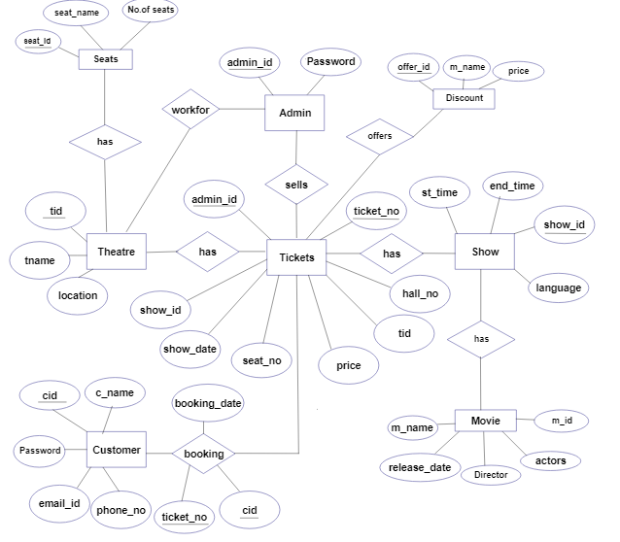

2.6 Database Design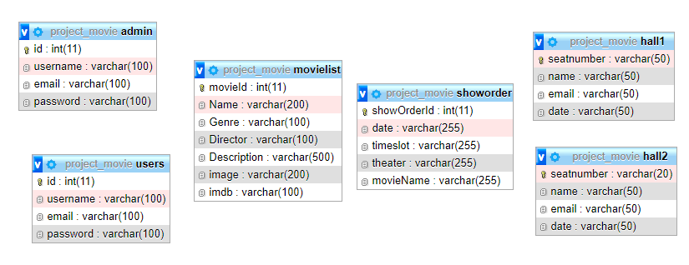

2.7 Tools and Platform

During the development of the project, the tools and platforms that we used for coding and testing the project are:

1. Sublime Text

2. Wamp Server

# CHAPTER 3

# RESULTS AND DISCUSSION

3.1 Overview

I have completed the project “Movie Ticket Booking System” using the specified languages. This project consists of booking of movie tickets and viewing of their schedules on the user side whereas in the admin side, it consists of the features like adding new movies, deleting old movies and updating the schedule of the movies.

This project is entirely developed and designed as per the requirements specified by our supervisior and is well designed for the proper utilization of the knowledge relating the scripting language like javascript and php applicating with mySQL for proper information storage.

3.2 Analysis of Result

We have worked the following components as below:

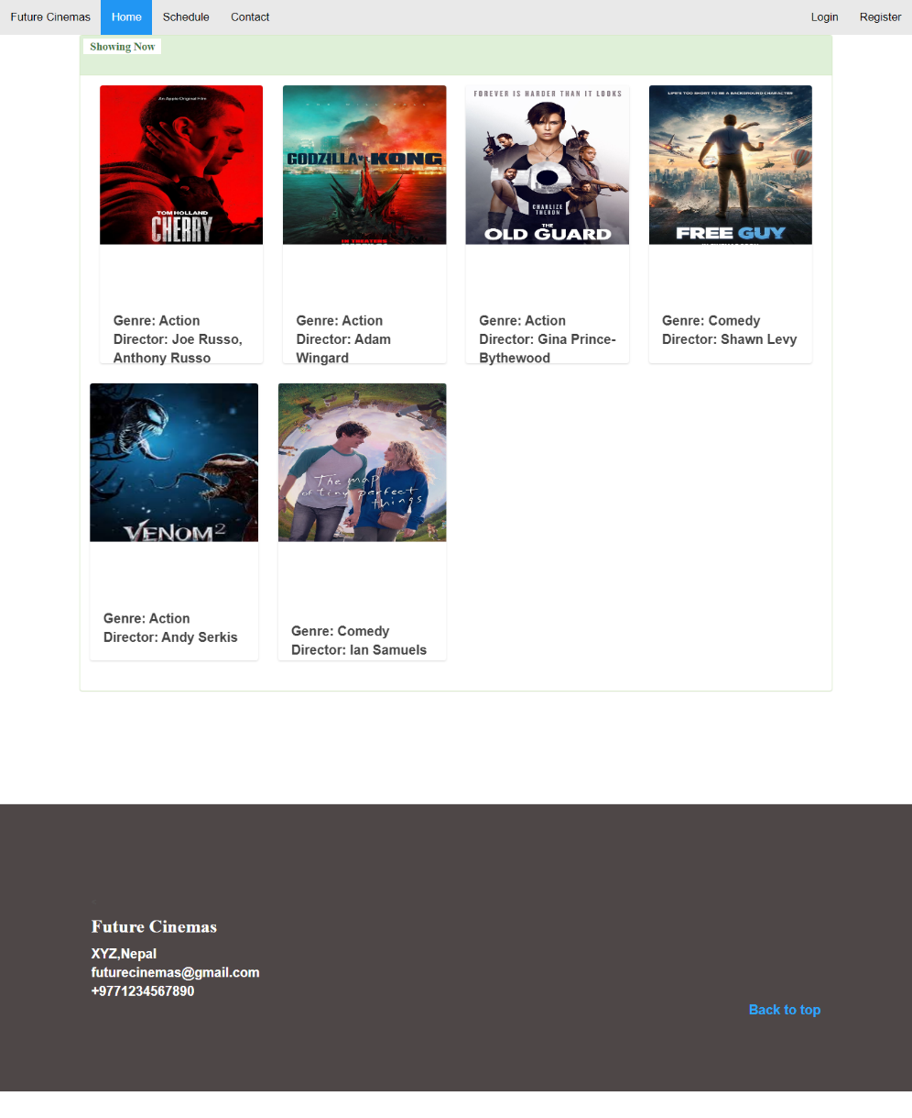

Fig:3.1 Home Page

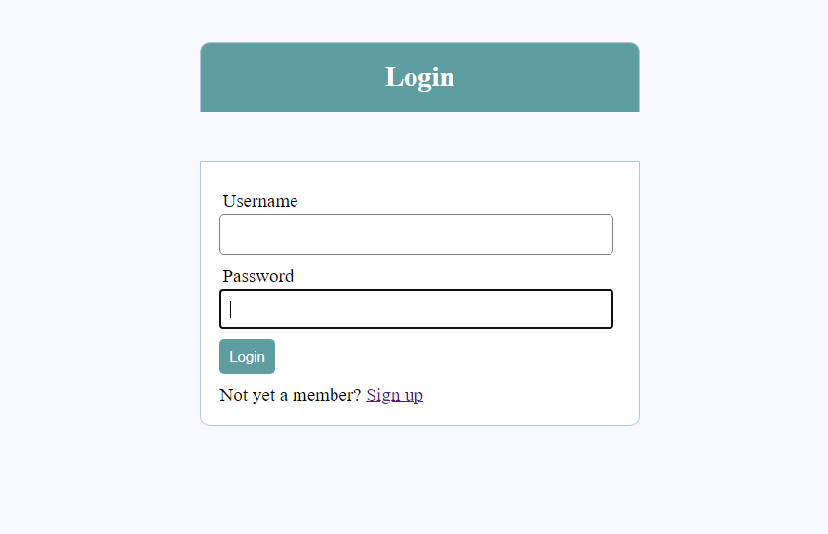

Fig:3.2 Login Page

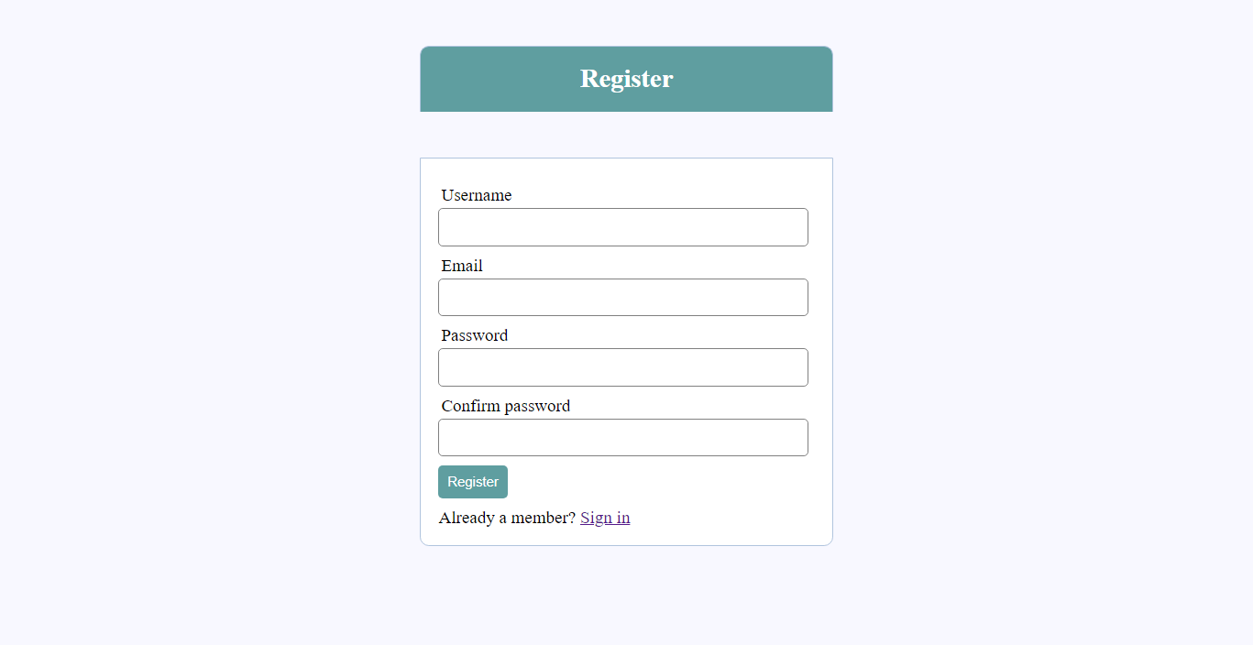

Fig:3.3 Register Page

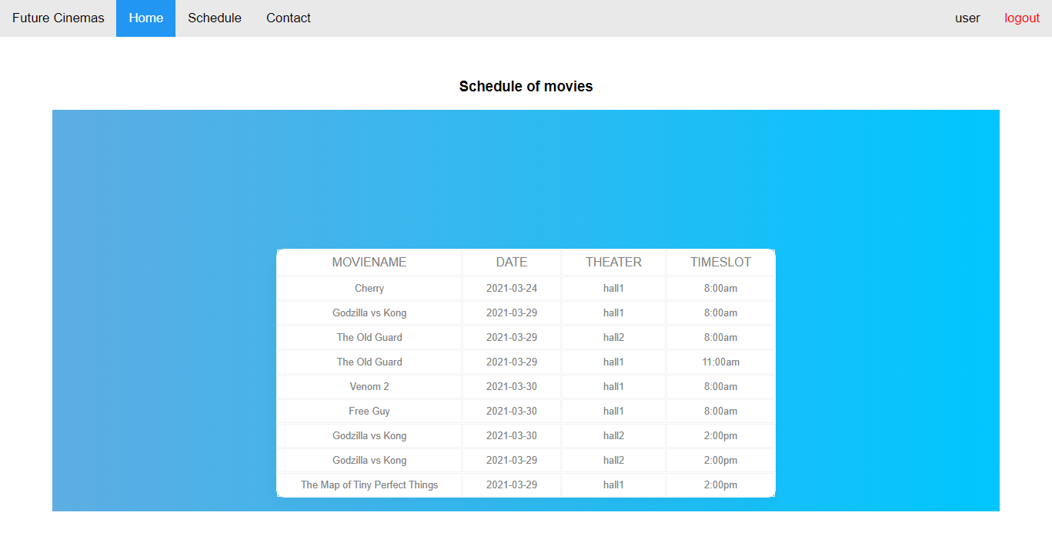

Fig:3.4 Movie Showlist

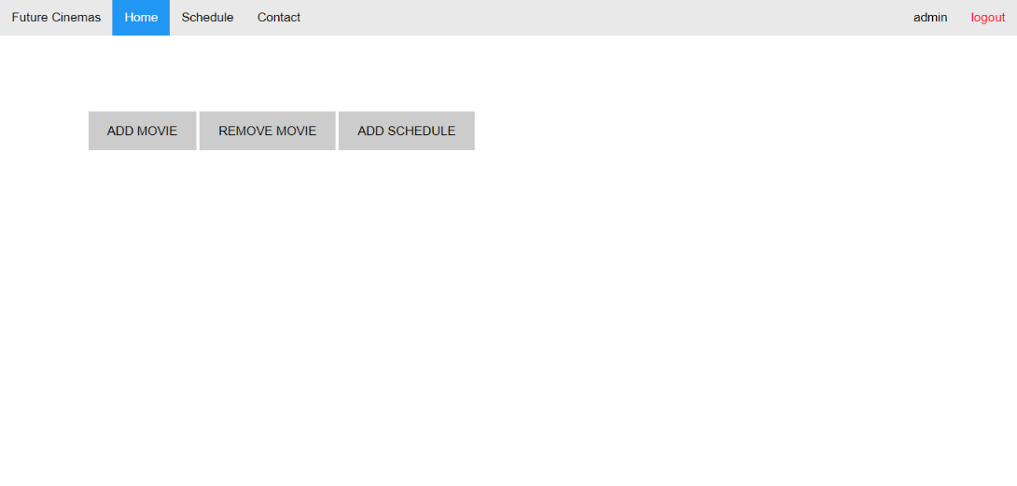

Fig:3.5 Admin main Page

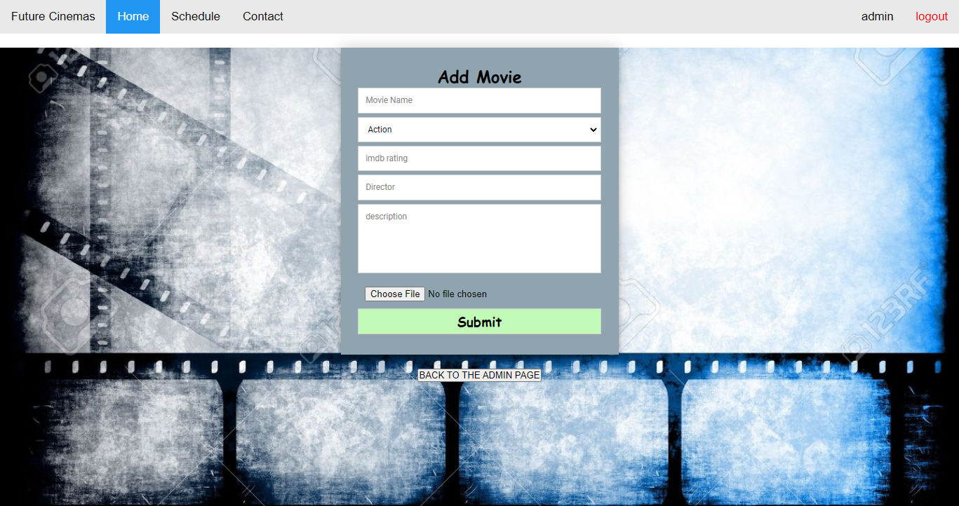

Fig:3.6 Add movie Page

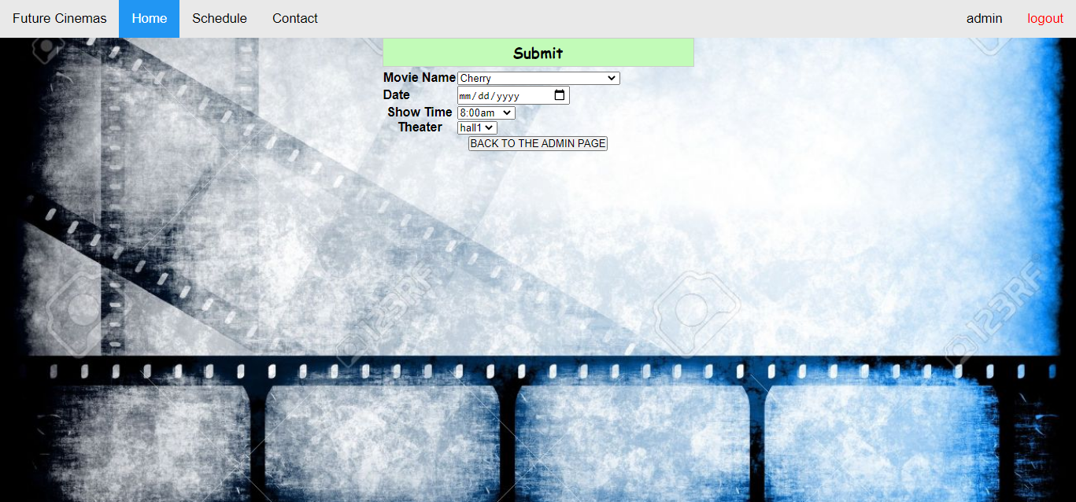

Fig:3.7 Add Schedule Page

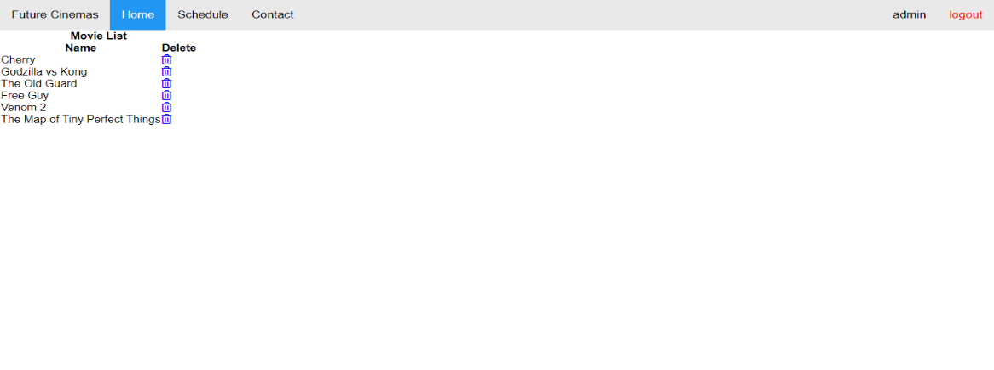

Fig:3.8 Delete Movie Page

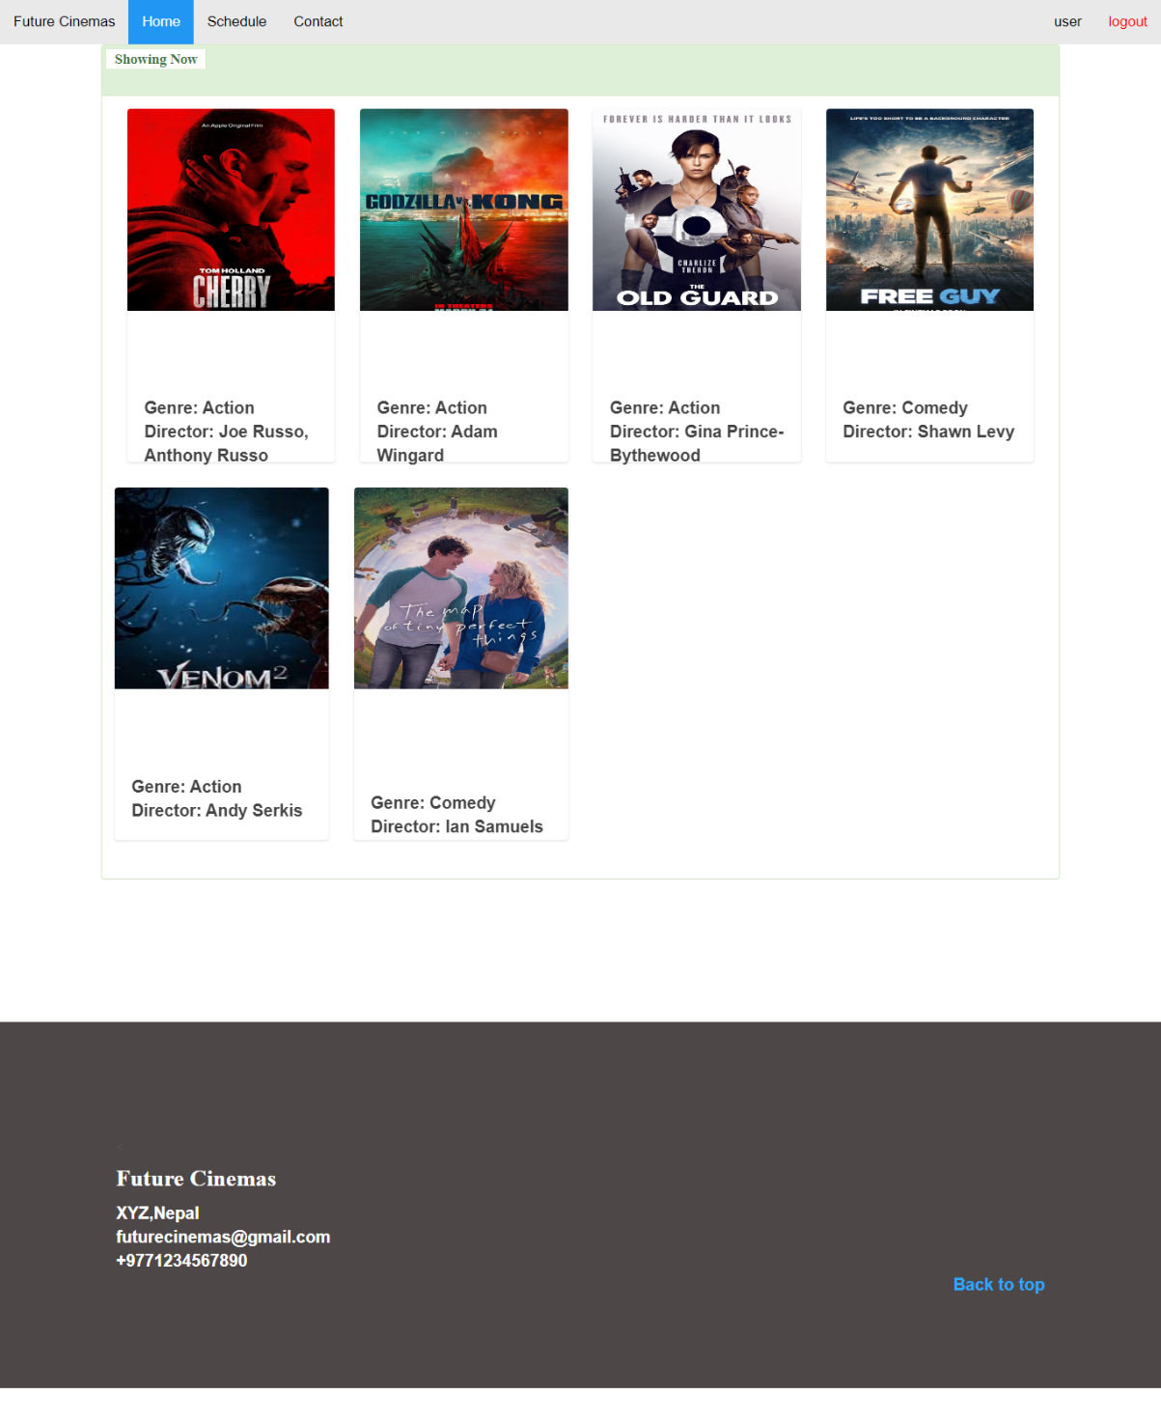

Fig:3.9 User main Page

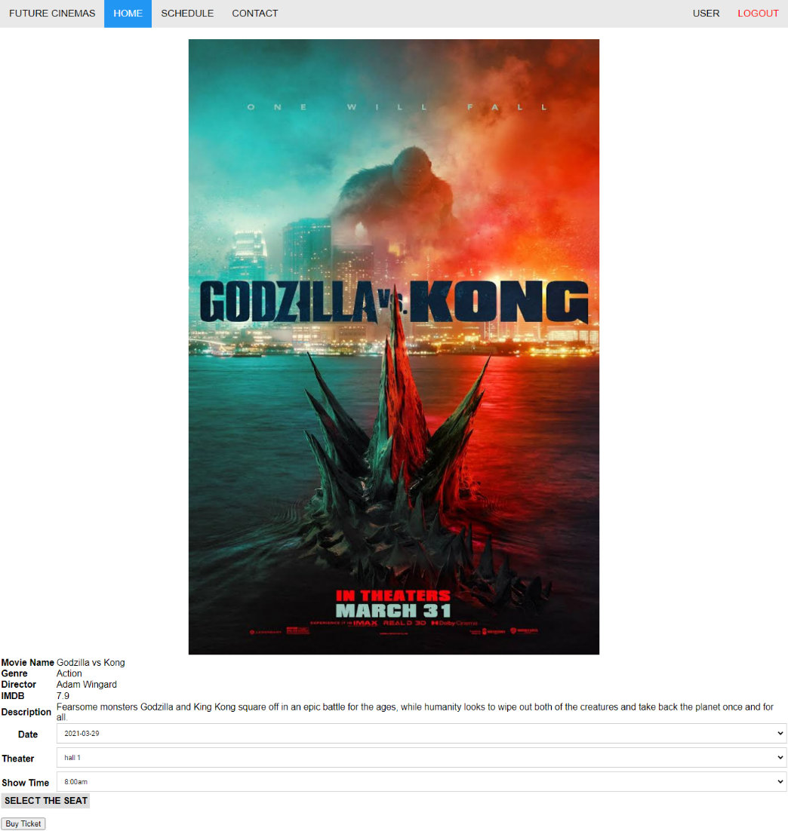

Fig:3.10 Book Ticket Page

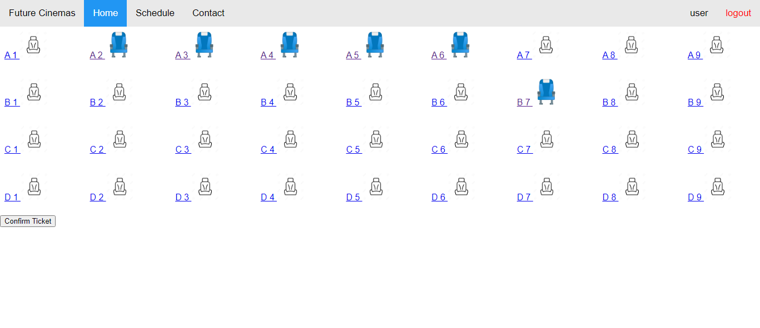

Fig:3.11 Select Seats Page

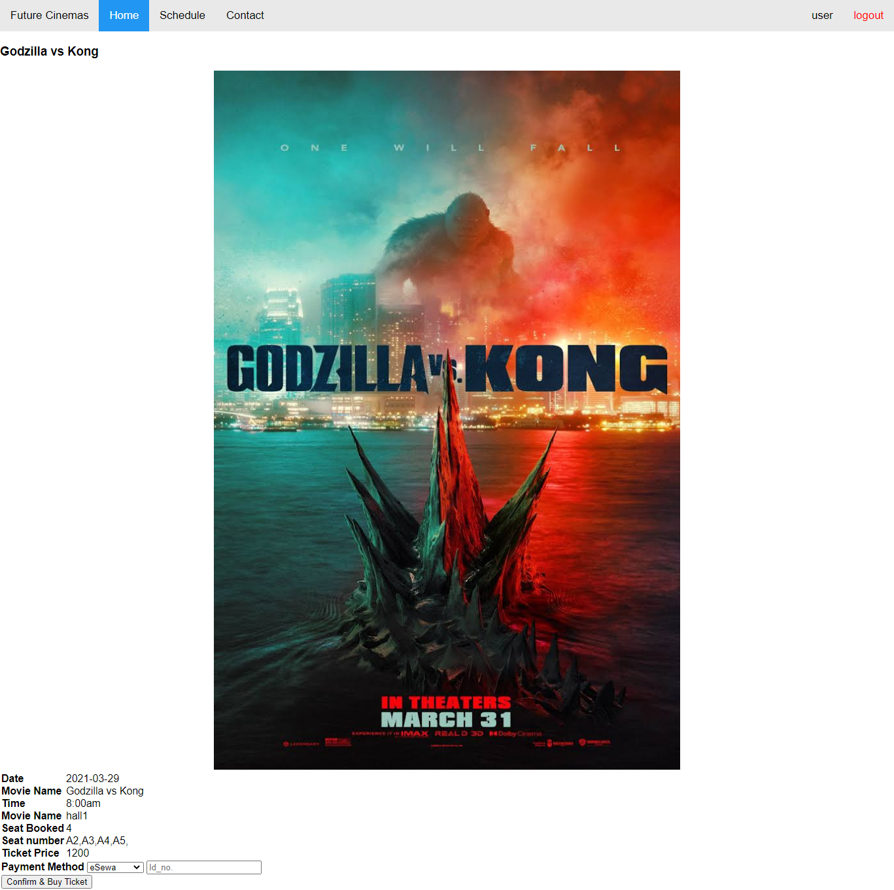

Fig:3.12 Confirm Tickets Page

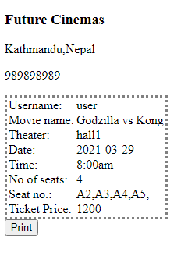

Fig:3.13 Print Ticket Page

# CHAPTER 4

# CONCLUSION AND RECOMMENDATION

4.1 Conclusion

Hence, after completion of the project we got familiar with the basic and high level scripting languages and its features. As a whole, this project has been good experience for us. We have gained knowledge about the various aspects of web design and database connectivity. At the same time we have developed a better understanding of mySQL database language.

Since the project is completed but there are still lots of room for improvement.

4.2 Future Enhancement

A Movie Ticket Booking System can be developed with the knowledge about html, javaScript, php and mySQL. This project is done with some basic knowledge and some research of scripting languages. Since we are beginner so there may be some flaws in the developed project. So, there are still improvements that can be done in our project.

1. The user interface can be drastically improved.
2. More information about the movies can be made to be add.
3. Selecting the seats menu can be improved.

# REFERENCES

1. https://www.freeprojectz.com/project-source-code-database-download/movie-ticket-booking-system-project [visited March 15, 2021]
2. https://github.com/projectworldsofficial/Online-Movie-Ticket-Booking-System-in-php [visited March 15, 2021]
3. https://www.w3schools.com/sql [visited March 15, 2021]